Licensing Executives Society of Japan
International Symposium
on Intellectual Property Management

LES Japan will be offering an international symposium in the English language featuring prominent speakers from leading multinational companies of the U.S.A, Germany and Japan. These top-level IP executives will discuss intellectual property management and its role in their corporations’ strategies. We believe we have put together an extremely informative and worthwhile symposium and expect to have a large turnout from both local and international practitioners. We look forward to seeing you there.

Kiyohide Okamoto
President LES Japan

Date: November 17, 2006 Friday
Time: Symposium: 1:30 p.m. to 4:45 p.m.
Reception: 5:00 p.m. to 7:00 p.m.
Place: KAIUN BLDG
6-4, Hirakawa-cho 2-Chome, Chiyoda-ku, TOKYO (Map attached)
Language: English (Japanese translation will not be provided)
Co-Sponsors: Japan Intellectual Property Association
Japan Institute of Invention & Innovation
Capacity: 150 persons (※)
Fees: LES, JIPA and JIII members (※)
Symposium: 5,000 yen;
Reception: 5,000 yen
(Non-members please contact the secretariat for details.)

Program
1:30-1:35 Opening; Kiyohide Okamoto, President LES Japan
1:35-3:35 Presentation “Intellectual Property Management in Companies”
Speakers;
- Mr. Mark Adler, Chief Patent Counsel, Rohm & Haas Co.
President, Intellectual Property Owners Association (U.S.A.)
- Dr. Bertram Huber, Senior VP, Head of Corporate IP, Robert Bosch GmbH, Past President LES Germany
- Mr. Hiroyuki Hirayama, Director of IP Division, Hitachi Ltd.,
Past Director LES Japan
3:35-3:50 Coffee Break
3:50-4:45 Panel Discussion
Panelists: Symposium’s speakers
Mr. Mark Adler, Dr. Bertram Huber, Mr. Hiroyuki Hirayama,

Moderator:
Mr. Junichi Yamazaki, Attorney at Law, Miyake & Yamazaki
Vice President LES Japan

5:00-7:00 Reception

◆ Application Deadline: November 10, 2006
- Accepted forms of Payment: Cash Only, Payment in cash on that day
(You will receive a copy of your receipt at the symposium.)
◆ Application: Please download and complete the form provided on the LESJ website. (Click Here)

- Applications are accepted on a first-come-first-served basis. The application period will close when all seats have been filled.
- If for any reason you are unable to attend, you may send an appropriate representative to attend the symposium.

- LESJ Secretariat Contact Information：
Mr. Katsuhiko Tachibana
Japan Institute of Invention & Innovation
2-9-14, Toranomon, Minato-ku,
Tokyo, 105-0001, JAPAN
TEL: 03-3595-0578
FAX: 03-3595-0485
E-mail： les@din.or.jp
Map:
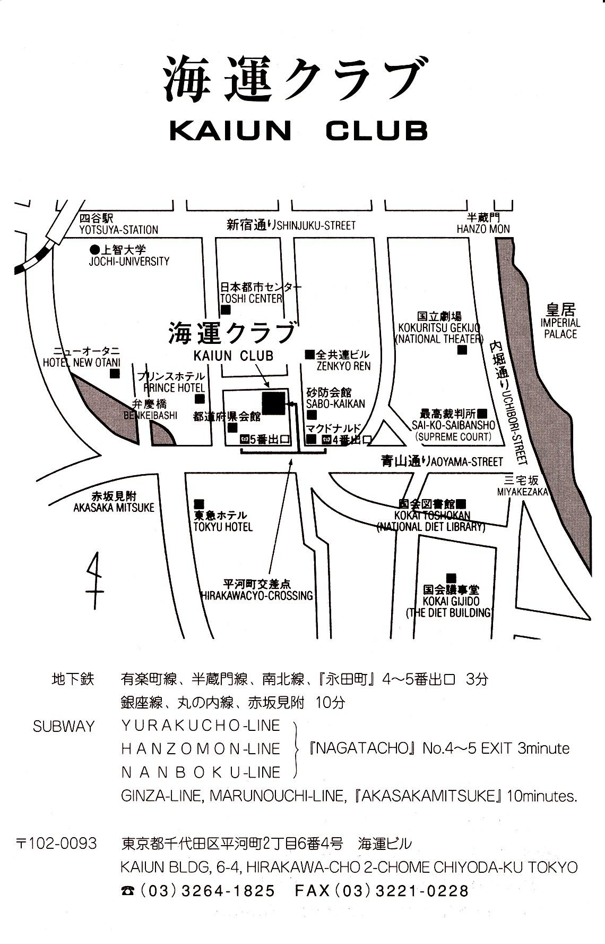

Speakers:

MARC S. ADLER

Marc is the Chief Intellectual Property Counsel and Assistant General Counsel of Rohm and Haas Company, a worldwide specialty chemicals and material company headquartered in Philadelphia, Pennsylvania. Marc received his BS ChE from the City College of New York, his MS ChE from the University of Florida, and his law degree (JD) from St. John’s University. Marc has been active in the Intellectual Property Owners Association, and the Association of Corporate Patent Counsel. Currently he is President of IPO and Immediate Past President of ACPC.

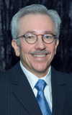

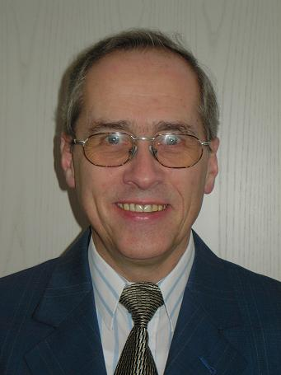
Dr. Bertram Huber

Senior Vice President, Robert Bosch GmbH, Stuttgart, Germany
Head of Corporate Intellectual Property

Born 1947, studied Law in Muenster and Tuebingen, he holds a Doctor degree in Law (Dr. jur.) of the University of Tuebingen. He started his professional career 1978 at AEG-Telefunken AG. 1983 – 1994 headed the Legal and Patents Department of ANT Nachrichtentechnik GmbH. Joined Robert Bosch GmbH in 1995. Since 2000 has been responsible for the global IP activities of the Bosch Group.
Educational stages in Brazil, other Latin American countries, and Spain. Extensive negotiation experience in particular in the field of technology transfer/licensing with main focus on China, Japan and other parts of Asia as well as Europe and North America.
Various publications encompassing in particular technology transfer to China and Brazilian inflation treatment.
Active in a number of IP organizations and professional IP expert groups: AIPPI (Programme Committee), Munich Intellectual Property Law Center (Board of Trustees), UNICE (Patents Working Group), BDI (Sonderausschuss Gewerblicher Rechtsschutz), GRUR, VPP, Past President of LES Germany.

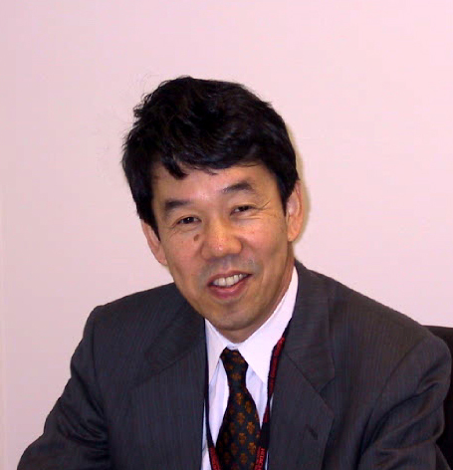

Hiroyuki Hirayama

Mr. Hiroyuki HIRAYAMA is a Corporate Officer and the Managing Director of Intellectual Property Group (IPG) of Hitachi Ltd., a global electronics conglomerate, whose products range from consumer electronics to hard disk drives, railway vehicles and power plants.
Mr. Hirayama received his LLB degree from Tohoku University and entered Hitachi Ltd in 1971. Before assuming his present position, he has served as the General Manager of License Department 1 of IPG, and more recently as the Vice President responsible for intellectual property in Hitachi Global Storage Technologies, Inc. in San Jose, California.
Mr. Hirayama also served as a member of Committee on Technical Standard and Competition Policy in the Japan Fair Trade Commission. Currently, he is the Commissioner of the Institute of Intellectual Property (Japan), the Vice President of Japan Design Protection Association, and the Commissioner of Tokyo Branch of Japan Institute of Invention and Innovation.

